Press Release
16. September 2026
InnoTrans 2026
Efficient, collaborative, digital – modern vehicle design at its best

Customization and efficient change management are essential when developing rail vehicles – because every vehicle needs to be adapted to individual requirements. At InnoTrans, the international leading trade fair for transport technology, AUCOTEC will show you how to reuse plans and functions without having to start from scratch every time.

The engineering software for rail vehicles!

Engineering Base is the data-centric development and collaboration platform for electrical systems and optimized vehicle wiring. The platform enables collaborative development across the entire electromechanical process for rail vehicles. Structured data and consistent process data from a single source make this possible.

The software also makes it easy to visualize and provide data and documents for service and manufacturing processes. The unique architecture of Engineering Base and the many years of experience of our AUCOTEC experts across all mobility sectors enable you to optimize your development, manufacturing and service processes – efficiently, flexibly and to a high standard of quality

Experience our engineering software live!
Visit us at Messe Berlin from September 22 to 25, 2026, Hall 6.2, Stand 995.

What change management in Engineering Base delivers:

Change management in AUCOTEC’s Engineering Base (EB) collaboration platform ensures maximum transparency, traceability and data consistency across all disciplines and throughout the entire plant life cycle.
Revision management & data history: Graphical revision management and Advanced Data Tracking make every modification to objects traceable down to the smallest level of detail.

Data history, delta management and revision management in Engineering Base:

In AUCOTEC’s Engineering Base (EB), the functionality for tracking project changes is known as Advanced Data Tracking, or revision management & data history. As Engineering Base is a fully database-driven platform with a single source of truth, this feature records changes directly in the data model – even before they become visible graphically in a plan.

- Object-specific data history: EB logs every modification to devices, cables, signals or attributes without gaps. At any level of detail, you can see who changed what and when.

- Automatic delta management: When exchanging data with external systems such as ERP, PLM or MCAD, the system automatically detects deviations (deltas) and accurately reconciles bills of materials.

- Graphical revision management: In addition to database attributes, graphical changes in circuit diagrams or cable plans are visually highlighted and versioned.
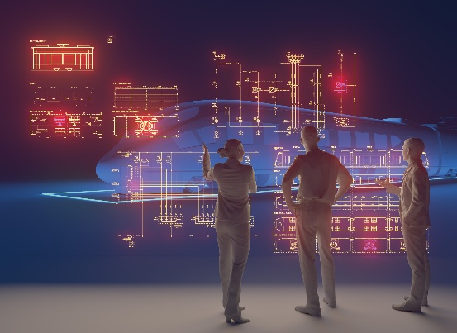
Railway Keyvisual (AI-generated with Adobe Firefly)


Georg Hiebl, Product Manager at Aucotec (Picture: Aucotec AG)

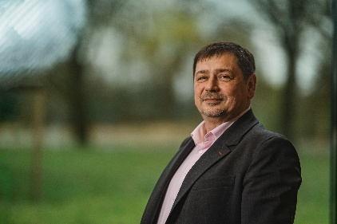
Marek Tabaczynski, Lead Application Consultant at Aucotec. (Picture: Aucotec AG)

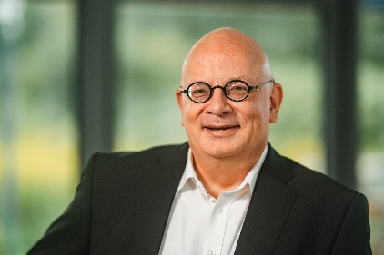
Sven Möller, Global Account Manager at Aucotec. (Picture: Aucotec AG)

*These images are protected by copyright. They may be used for editorial purposes in connection with AUCOTEC.

___________________________________________________________________________
Aucotec AG develops engineering software for the entire lifecycle of machines, plants, and mobile systems – backed by more than 40 years of experience. Its solutions range from process diagrams and instrumentation and electrical engineering for large-scale plants to modular wiring systems in the automotive industry. AUCOTEC software is used worldwide. In addition to its headquarters near Hanover, the AUCOTEC Group includes six further locations in Germany as well as subsidiaries in China, India, Malaysia, South Korea, the Netherlands, France, Italy, Austria, Poland, Sweden, Norway, and the USA. A global partner network also ensures local support around the world.
If published, we kindly request a specimen copy. Thank you!

Contact:
AUCOTEC AG, Hannoversche Straße 105, 30916 Isernhagen, www.aucotec.com
Public Relations (presse@aucotec.com +49(0)511-6103192)

