Press Release
14. July 2026
CIGRE 2026

AUCOTEC makes digital substations manageable
At CIGRE 2026 in Paris, AUCOTEC will demonstrate how data-centric engineering can sustainably accelerate grid expansion. With Engineering Base 2026, the software company is presenting the next evolutionary stage of its platform for building and operating digital substations. The focus is on new rule-based engineering capabilities for IEC 61850, the world’s first full integration of the standard into an end-to-end engineering platform, and a consistently data-driven approach across the entire life cycle of power infrastructure.

Expanding power grids is one of the greatest infrastructure challenges facing the world in the coming decades. At the same time, requirements for digitalization, interoperability, and engineering efficiency continue to increase. Digital substations are increasingly based on data models, servers, and communication networks rather than purely physical wiring. As a result, document-centric engineering methods are increasingly reaching their limits.
With its collaborative Engineering Base platform, AUCOTEC is therefore pursuing a consistently data-centric approach. The company was the first provider worldwide to fully integrate IEC 61850 directly into its collaborative platform. At CIGRE 2026, AUCOTEC will now showcase the next stage of this development.
More Automation, Less Complexity
With Engineering Base 2026, IEC 61850 is not only fully integrated but also significantly easier to manage thanks to new rule-based capabilities. Predefined rule sets help users build standards-compliant data models consistently and validate them automatically. New assistants guide users through the configuration of intelligent electronic devices (IEDs), reducing common sources of error during the engineering process.
The functional data models remain directly linked to the physical devices. All disciplines involved—from primary equipment through protection and control engineering—work in parallel using a shared data foundation. Changes are tracked automatically, eliminating data discontinuities between systems.
“With Engineering Base 2026, we are not only making IEC 61850 integrable—we are making it manageable,” explains Michaela Imbusch, Product Manager Power Transmission & Distribution at AUCOTEC. “Our rule-based validation ensures that consistent, standards-compliant data models are created from the outset. This reduces complexity and lays the foundation for significantly more efficient engineering processes.”

Today, many delays in the expansion of modern power infrastructure are caused less by a lack of expertise than by fragmented data and time-consuming coordination between different engineering disciplines.
One Platform Instead of a Patchwork of Tools
By fully integrating all engineering disciplines, the need for external tools can be significantly reduced. Functional models, hardware, signal data, and documentation are interconnected within a shared platform. This simplifies IT landscapes, improves data quality, and noticeably shortens engineering timelines.
Particularly in view of worldwide grid expansion, this approach creates the conditions needed to complete projects more quickly while meeting the highest quality and safety requirements.
Automation Accelerates Engineering Processes
The end-to-end data foundation also creates the basis for further automation throughout the engineering process. AUCOTEC’s Project Builder, combined with the Advanced Typical Manager (ATM), delivers additional efficiency gains.
While the ATM automatically inserts standardized functional modules into projects, the Project Builder handles their rule-based selection and configuration. Time-consuming manual assignments are eliminated, while reliance on specialized expertise is reduced. Standardized engineering solutions can be generated consistently and reproducibly. Reusable project standards, automated documentation, and significantly less rework noticeably shorten engineering timelines. This enables power infrastructure projects to be completed more quickly despite tight schedules and limited resources.
Engineering Base replaces document-centric working methods with a consistent data model. Standards such as IEC 61850 and IEC 81346 are not documented after the fact but are integral components of the entire engineering process. This creates an end-to-end digital twin that supports planning, construction, operation, and modernization alike.
“A digital substation is not created through individual software tools, but through consistent data across the entire life cycle,” says Imbusch. “That is exactly what Engineering Base was developed to provide.”
AI Diagram Import Significantly Accelerates Digitization
AUCOTEC is also using automation to digitize existing installations. At CIGRE 2026, the company will present AI Diagram Import (AIDI), an AI-powered solution for this purpose. The technology automatically converts circuit diagrams and plant documentation into structured engineering data for Engineering Base. This allows existing assets to be digitally captured much more quickly, eliminates disruptive data handoffs, and enables digital twins to be created efficiently. Modernization and expansion projects supporting the energy transition can therefore be completed faster and more cost-effectively.

Images* and Captions:

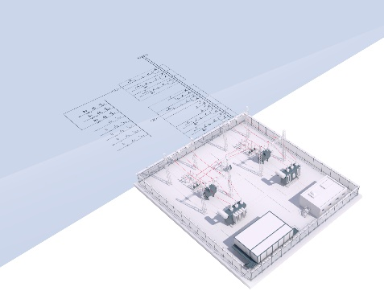
Transparent, continuously up-to-date digital twin of the substation in Engineering Base. (Image: AUCOTEC)


Michaela Imbusch, Product Manager at AUCOTEC AG. (Image: AUCOTEC)

*These images are protected by copyright. They may be used for editorial purposes in connection with AUCOTEC.

___________________________________________________________________________
Aucotec AG develops engineering software for the entire life cycle of machinery, plants, and mobile systems—backed by more than 40 years of experience. Its solutions range from flow diagrams and control and electrical engineering for large-scale plants to modular vehicle electrical systems for the automotive industry. AUCOTEC software is used worldwide. In addition to its headquarters near Hanover, the AUCOTEC Group operates six other locations in Germany as well as subsidiaries in China, India, Malaysia, South Korea, the Netherlands, France, Italy, Austria, Poland, Sweden, Norway, and the United States. A global partner network also ensures local support worldwide.

If published, please send us a complimentary copy. Thank you.

Contact:

AUCOTEC AG
Hannoversche Straße 105
30916 Isernhagen
www.aucotec.com

