Press Release
July 30, 2025
40 years of Aucotec
From Software Pioneer to Digital Nervous System for Industry
- Aucotec celebrates its anniversary as a leading international provider of engineering software
- The Engineering Base cooperation platform links all disciplines in plant engineering
- Internationalization and technological innovation continue to be key growth drivers

Aucotec AG is celebrating its 40th anniversary. What began in 1985 as a vision has grown into a globally renowned provider of engineering software that today supplies key technologies for digitalization and automation of industrial processes – technologies such as the Engineering Base platform.

Engineering Base: the backbone of modern industrial plants
From mechanical engineering to power distribution to the process industry – modern plants require end-to-end data models and interdisciplinary collaboration. Engineering Base brings together all areas of engineering in one central system, automates processes and paves the way for a consistent digital twin that serves as the basis for forward-looking, sustainable solutions.
"Interconnectivity and parallelization are crucial in engineering today," emphasizes Aucotec Board Member Uwe Vogt. "Our platform offers the necessary flexibility and future-proofing to consistently meet these requirements."

From Elcad to Engineering Base – 40 years of progress
Aucotec started out with its first products, Elcad and Ruplan, in the 1980s before later developing solutions such as AUCOPLAN and finally Engineering Base – to unite all core disciplines of plant engineering in a central data model – in 2018. "Over the years, Engineering Base has evolved into the real centerpiece of plant engineering, for us and our customers alike," says Horst Beran, CEO and co-founder of Aucotec.

Globally connected: new locations and powerful partners
Aucotec has been on a growth trajectory for some time now, especially at an international level. With new offices in Poland, Sweden, South Korea, Norway, India and Malaysia, the company is getting closer to customers and markets. Long-standing partnerships with renowned industrial companies from all over the world as well as its most recent collaborations with Aker BP and Westfalen AG all testify to Aucotec's role as a dependable technology partner on the road to Industry 4.0.

Aucotec has also revamped its online presence to coincide with its anniversary, creating a fresh new design and clearly structured path to solutions and services at www.aucotec.com.

Looking ahead: artificial intelligence and digital twins
For the future, Aucotec will be focusing on AI-based applications and the further expansion of Engineering Base as an intelligent cooperation platform. "We strive to always be one technological step ahead and to enable our customers to use innovations in just the way they need," says Vogt. And Beran adds: "Today, we are a leading provider of model- and data-driven processes – and that is down to our great team, who have always been the foundation for what we do. This is how we shape the future of engineering – efficiently, digitally and sustainably."

Images* and captions:

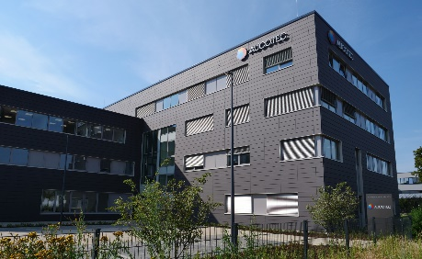
Aucotec headquarters in Isernhagen near Hanover. (Image: Aucotec AG)
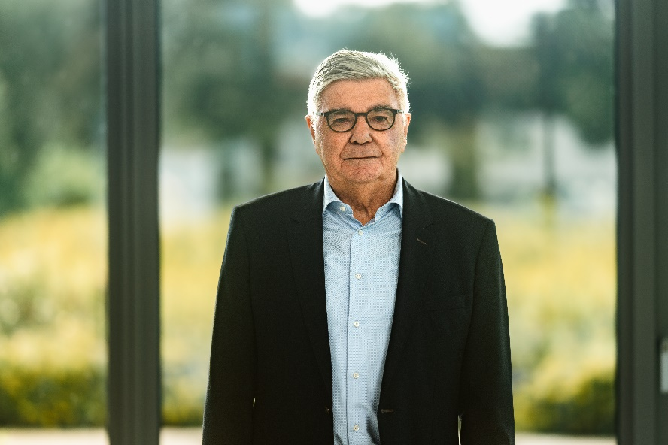
Horst Beran, CEO of Aucotec AG. (Image: Aucotec AG)


Uwe Vogt, Member of the Executive Board of Aucotec AG. (Image: Aucotec AG)

*These images are protected by copyright. They may be used for editorial purposes in connection with Aucotec.

___________________________________________________________________________
Aucotec AG has almost 40 years' experience in the development of engineering software designed for use throughout the life cycle of machinery, plant equipment and mobile systems. Solutions range from flow diagrams and process-control/electrical technology for large-scale plant systems to modular on-board power supply units designed for the automotive industry. Software supplied by Aucotec is currently in operation throughout the world. In addition to the headquarters near Hanover, the Aucotec Group includes six other locations in Germany as well as subsidiaries in China, India, Malaysia, South Korea, the Netherlands, France, Italy, Austria, Poland, Sweden, Norway and the USA. What is more, a global partner network ensures local support all over the world.
We would be grateful if you could supply us with a copy of your article. Thank you very much!

Contact:
AUCOTEC AG, Hannoversche Straße 105, 30916 Isernhagen, www.aucotec.com
Public Relations, Arne Peters (arne.peters@aucotec.com +49(0)511-6103192)

