Press Release
17 May 2022

More subsidiaries, more experts
Strong figures despite global crises - Aucotec continues to expand

Aucotec AG, an independent medium-sized engineering software developer since 1985 with headquarters in Hanover, Germany, continues to grow: just in time for the new financial year on 1 April 2022, the subsidiary Aucotec Netherlands B.V., based near Rotterdam, was founded to cover the Benelux region. Aucotec India Private LTd. in Pune followed on 1 May. "We believe in on-the-ground presence and in Asia's enormous potential. So far, partners have represented us in India and the Netherlands, but now we want to become more visible, invest more in sales and be able to trade more directly," says board member Uwe Vogt. The Indian subsidiary will become part of Aucotec's Asia-Pacific focus, which will be expanded as a resource pool for the region. In Asia, Aucotec already has companies in China and South Korea.

The subsidiaries' share in Aucotec's success has been growing for years. In the previous financial year, the Chinese branch achieved its best result ever, with an increase of about 70 %. In the current year, the subsidiaries in Italy (+ 58 %), Korea (+ 45 %) and Austria (+ 15 %) are enjoying record turnover. Aucotec Shanghai Co., Ltd. on the other hand, recorded "only" the second-best result in its long history, according to the preliminary figures. However, the moderate target set due to corona-related imponderables was exceeded by more than 30 %.

From Mobility to Energy Infrastructure
According to preliminary results for 2021/22, German Aucotec AG's turnover of just under €23 million did not quite match the previous year, which was still the second-best end-of-year financial statement in the company's history after an all-time record in 2019/2020. "The development of Aucotec AG as well as the whole group has been solidly on a high level for years, despite the burdens that Corona has imposed on us and despite the horrendous Ukraine war, which has already influenced the current financial statement," says Vogt. "It shows that the scope of our Engineering Base (EB) platform, which offers a portfolio for industries ranging from mobility and process and electrical plants to energy infrastructure, is just right. This is because the turnover achieved is spread across all four areas," says the Member of the Executive Board. The biggest successes of the year include orders from both the power generation and rail vehicle sectors (China), as well as trucks & buses, power distribution and petrochemical industries (Europe), and especially in Austria and Scandinavia from pulp & paper companies.

Further investment
Aucotec is therefore currently continuing to focus on its growth strategy with investments in personnel, qualification and the subsidiaries. After the number of employees had already risen by around 40 % in the previous ten years (and turnover by a good 100 %), it increased again by a good 5 % to over 240 in the Aucotec Group, and by over 10 % in China alone. It is not just a slogan when employees are described as the biggest "asset", emphasizes Uwe Vogt. Their commitment and flexibility had ensured that there was hardly any loss of performance due to Corona - despite severe restrictions on travel and face-to-face meetings. "We always win customers over by Aucotec's personality as well. The fact that this worked even with completely new customers only using video, shows what a great team we have," praises Member of the Board Vogt.

Links to images*:

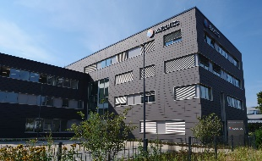(©: AUCOTEC AG | Link) 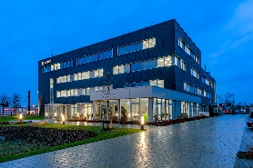 (©: Mitsubishi Electric | Link)

Caption: Aucotec AG, an independent medium-sized engineering software developer with headquarters in Hanover since 1985, continues to grow

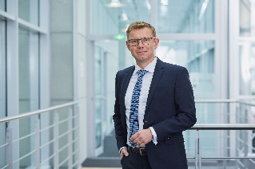

Caption: Uwe Vogt, Aucotec Management Board : "We always win customers over by Aucotec's personality as well. The fact that this worked via video, even with completely new customers, shows what a great team we have."
(© AUCOTEC AG)

*These images are protected by copyright. They may be used for editorial purposes in connection with Aucotec.

___________________________________________________________________________
Aucotec AG has more than 35 years’ experience in the development of engineering software designed for use throughout the life cycle of machinery, plant equipment and mobile systems. Solutions range from flow diagrams and process-control/electrical technology for large-scale plant systems to modular on-board power supply units designed for the automotive industry. Software supplied by Aucotec is currently in operation throughout the world. In addition to the headquarters in Hanover, the Aucotec Group includes six other locations in Germany as well as subsidiaries in China, India, South Korea, the Netherlands, France, Italy, Austria, Poland, Sweden, Norway and the USA. What is more, a global partner network ensures local support all over the world.

We would be grateful if you could supply us with a copy of your article. Thank you very much!

AUCOTEC AG, Hannoversche Straße 105, 30916 Isernhagen, www.aucotec.com
Press and Public Relations, Johanna Kiesel(johanna.kiesel@aucotec.com,+49(0)511-6103186)

