Press release
20 July 2021

More projects, less costs
Data-driven approach is key milestone for Haldor Topsoe's Engineering

The Danish company Haldor Topsoe, which is heavily involved in the green energy transition from its electrolysis expertise as well as being a catalyst expert, technology licensor and process engineering leader has now ushered in a new era of digital, cooperative engineering with Aucotec's platform Engineering Base (EB). Topsoe, one of the world's leading technology providers for the chemical and petrochemical industry, symbolically marked the start of the company-wide use of EB with a loud siren at the end of May. 'The introduction of this system is a key milestone in our digital transformation', explained Topsoe's CIO Niels Keller-Larsen at the go-live in which more than 100 engineers, managers and project managers participated.

Moon landing for engineering
'With EB, we are finally working in a truly data-driven manner across all engineering phases and disciplines on one data model!' emphasized Keller-Larsen. The migration to the platform is Topsoe's largest IT transformation project to date. 'Our moon landing, so to speak', said the top IT Manager. As a knowledge base for everyone involved, EB supports projects from their "birth" to the very end and offers customers a continuous customer journey. Furthermore, EB standardizes Topsoe's system environment and engineering; numerous discipline-specific tools have been replaced. 'With them, this transformation would never have been possible. As a single source of truth, EB also lays the foundation for AI use.

Partner rather than supplier
The (petro)chemical professionals attached great importance to having to order as few special solutions as possible for their engineering ideal. Thus, EB was chosen. 'However, today's platform differs from how it was at the start of the partnership with Haldor Topsoe', said Aucotec Executive Officer Uwe Vogt. The partnership led to the joint creation of several new developments that are important efficiency drivers for EPCs, plant engineers and operators, such as EBML for faster data exchange or the automatic data sheets of Asset 360. 'Both are now part of the standard in EB's plant license, thus they benefit all customers', reported Vogt with a touch of pride. Furthermore, Keller-Larsen added: 'We wanted a partner, not a supplier. The implementation and pilot project have shown that this has been successful.'

Six weeks instead of six months
'The transformation process was complex and very democratic. Never before have we brought together so much expertise and knowledge', said Keller-Larsen. Everyone had to rethink, but they now have a uniform "data home" for the entire engineering and maintenance tasks. This increases flexibility and saves around 10% of costs. Due to considerable acceleration – some work now takes six weeks instead of six months – significantly more projects will be able to be created within the same time in the future according to Niels Keller-Larsen.

Links to images*:
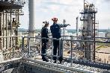
Topsoe delivers engineering services from the earliest phases of a project to technical services throughout the facility’s lifespan. (source: Haldor Topsoe)

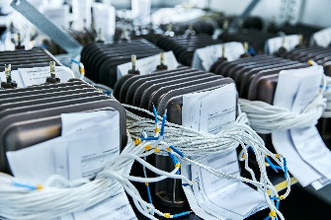
Topsoe’s SOEC electrolysis technology is up to 30 more efficient than standard
technologies. (source: Haldor Topsoe)

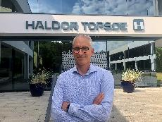
Niels Keller-Larsen, CIO at Haldor Topsoe: “With EB, we are finally working in a truly data-driven manner across all engineering phases and disciplines on one data model – our moon landing, so to speak.” (source: Haldor Topsoe)

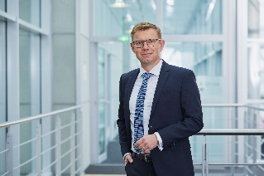
Uwe Vogt, Aucotec Executive Officer: “The partnership led to the joint creation of important efficiency drivers for EPCs, plant engineers and operators”
(source: AUCOTEC AG)

*These images are protected by copyright. Free editorial use is permitted in connection with this press release. Otherwise the photos are subject to the conditions of the relevant copyright holder.

If printed, we would appreciate receiving a copy. Thank you very much!
AUCOTEC AG, Hannoversche Straße 105, 30916 Isernhagen, www.aucotec.com
Press and Public Relations, Johanna Kiesel (jki@aucotec.com, +49 (0)511 6103186)

___________________________________________________________________________

Aucotec AG has over 35 years of experience in developing engineering software for the entire lifecycle of machines, plants and mobile systems. The solutions range from flow diagrams via I&C and electrical engineering for large-scale plants to modular harness design in the automotive industry. Aucotec software is in use all over the world. In addition to its headquarters in Hanover, Aucotec operates six further sites in Germany as well as subsidiaries in China, South Korea, France, Italy, Austria, Poland, Sweden, Norway and the US. A global network of partners ensures local support throughout the world.

Haldor Topsøe is a global leader in supply of catalysts, technology, and services to the chemical and refining industries. Topsoe aims to be the global leader within carbon emission reduction technologies by 2024. By perfecting chemistry for a better world, the company enables its customers to succeed in the transition towards renewable energy. Topsoe is headquartered in Denmark and serves customers around the globe. The company has 2,100 employees and achieved revenue of approximately 6,200 billion DKK in 2020. (www.topsoe.com)

