Press Release
04 May 2021

Aucotec at ACHEMA Pulse: EPC solutions in focus
Engineering Base consolidates data and simulations

At ACHEMA Pulse, Aucotec AG will be showcasing new solutions that primarily target the engineering challenges faced by EPCs in process plant engineering. To this end, the software provider has expanded its Engineering Base (EB) cooperation platform with automatically generated cross-discipline datasheets that significantly improve consistent communication with clients and subcontractors. In addition, a greatly simplified, standardized data exchange ensures faster integration of simulations, calculations and other data from complementary tools.

"EPCs suffer especially from time pressure, lack of resources and gigantic amount of work involved in changes. We have developed the new solutions hands on with customers and now want to attract more EPCs for EB's data-centric approach," says Aucotec CEO Uwe Vogt.

Consolidations through versatile data model
The decisive basis for the innovations is EB's versatile data model, on which all core engineering disciplines work centrally, jointly and in parallel. Since in this way all data on all devices and objects of a plant are consolidated across disciplines in a single source of truth, EB "understands" the directly imported simulation results of the various calculation tools immediately and flags up possible discrepancies straight away. This also consolidates the various calculation results in EB, eliminating manual data transfers and time-consuming comparisons. For EPCs juggling numerous tools, this data bundling pays off especially well.

A new open standard has been created for fast import into EB's data model. The XML-based EBML format "funnels" even highly complex data into the platform in the shortest possible time – no programming work or special system knowledge is required.

Data sheets automatically
The results of calculations, for example of different load conditions of a process reactor, usually have to be entered into so-called datasheets. They serve as a decision-making basis for the engineers for the final design of the reactor. Datasheets also go to customers for approval or to subcontractors for execution. They are one of the most important means of communication, so they require appropriate attention and input. With EB, these data sheets are automatically generated from the model. Templates, in which the calculation results consolidated by EB "land" immediately and without transmission errors, can be configured for this purpose.

Versatile model as a recipe for success
At the last attendance at ACHEMA, Aucotec had presented the versatile data model and the considerable bandwidth extension of EB for the first time. "This has convinced many new major customers, such as Equinor or Voith," reports Uwe Vogt. Two record sales years in a row prove the market's confidence in this concept.

Aucotec at ACHEMA Pulse 21: Register here free of charge!

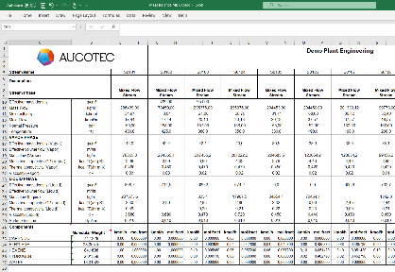
Links to images*:

Caption: Automatic datasheets save manual work and transmission errors: With EB, simulation results end up directly in suitable datasheet templates. (Example: Results of a heat & material balance calculation)
Or (shorter): Automatically generated data sheet from a heat & material balance calculation: This way EB saves manual work and transmission errors (Image: AUCOTEC AG)

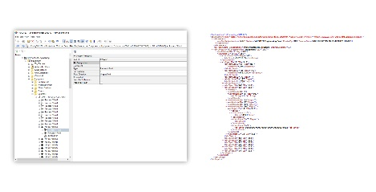
Caption: Accelerated data exchange: EBML automatically "translates" the information from EB (left) into an XML-based standard format (right) (Image: AUCOTEC AG)

Caption: Uwe Vogt, Aucotec Executive Officer: “We have developed the new solutions hands on with customers and now want to attract more EPCs for EB's data-centric approach." (Image: AUCOTEC AG)

*These images are protected by copyright. They may be used for editorial purposes in connection with Aucotec.

We would be grateful if you could supply us with a copy of your article. Thank you very much!
AUCOTEC AG, Hannoversche Straße 105, 30916 Isernhagen, www.aucotec.com
Press and PR Officer, Johanna Kiesel (jki@aucotec.com, +49(0)511-6103186)

___________________________________________________________________________
Aucotec AG has more than 35 years’ experience in the development of engineering software designed for use throughout the service life of machinery, plant equipment and mobile systems. Solutions range from flow diagrams and process-control/electrical technology for large-scale plant systems to modular on-board power supply units designed for the automotive industry. Software supplied by Aucotec is currently in operation throughout the world. Hanover-based Aucotec also operates six further sites in its home country of Germany, along with subsidiaries in China, South Korea, France, Italy, Austria, Poland, Sweden, Norway and the United States, while counting on a global network of partners to supply local support throughout the world.

