Press release
22 September 2021

Faster together
Infraserv Höchst opts for new level of digitization in engineering

Infraserv Höchst (ISH), operator of Industriepark Höchst and an expert in chemical-related services with over 100 sites in Germany, has opted for a paradigm shift in engineering. With Aucotec's platform Engineering Base (EB), Infraserv Höchst is gradually switching to cross-disciplinary work in a common data model in production and engineering. EB covers all engineering topics from P&IDs via instrumentation to maintenance. To date, ISH has used separate tools in each case.

Synergies in several areas
One of the first projects for the new holistic solution is a power plant modernization. For this purpose, the legacy data of the old plant is being migrated with Aucotec support and prepared with EB for optimal use in the data model. Aucotec has a sophisticated concept with an easily integrated standard interface that enables very fast data transmission of various formats. 'Further migration projects to EB will start in 2022. In this way, other areas of the company and 13 subsidiaries can benefit from the new software solution', reported Dr. Robert Schleich, Head of Engineering at ISH. As the person responsible for both process engineering and technical plant supervision, he stressed: 'The cross-disciplinary principle of EB enables synergies in the areas of data transmission, interfaces and IT work. It also ensures that we avoid mistakes in our cooperation with suppliers.'

In addition to the gas turbine modernization, a new gas turbine power plant will be one of the first EB projects. The cooperation platform is very experienced in the energy supply sector and is a proven expert in power plant designation and documentation in accordance with VGB standard 831.

The potential of the single source of truth
ISH has already had good experience with EB in the I&C design sector. 'However, the system only displays its full efficiency potential by merging the disciplines. Change management alone through EB as a single source of truth is so much more consistent, faster and easier', explained Edgar Heep, Head of Production Engineering for I&C at ISH.

Aucotec Executive Officer Uwe Vogt can only confirm this fact: 'We have decades of experience with discipline-specific software – for mechanical engineers, instrumentation engineers, energy supply experts and others. But the decisive factor is no longer the further refinement of individual tools in order to be the "best in the class" in certain areas. Today, the focus is on linked data and its universal availability, which is why the "most complete model" counts. Infraserv Höchst's switch to increased cooperation is a prime example of this and shows once again that we have taken the right path with Engineering Base.'

Links to images*:

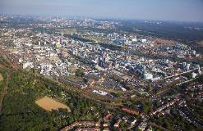
Industriepark Höchst: Around 90 companies with a total of around 22,000 employees over 460 hectares (Image: Infraserv Höchst)

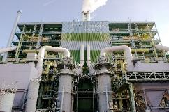
Sewage sludge incineration plant in Industriepark Höchst (Image: Infraserv Höchst)

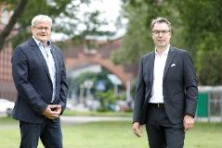
Dr. Robert Schleich (right), Head of Engineering at ISH: 'EB's cross-disciplinary principle enables synergies and ensures that we avoid mistakes.'

Edgar Heep (left), Head of I&C Design Industrial Engineering at ISH: 'EB only displays its full efficiency potential by merging the disciplines.'
(Image: Infraserv Höchst)

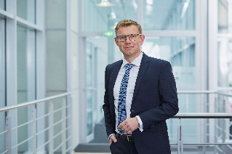
'The "most complete model" instead of the "best in the class": Today, the focus is on linked data and its universal availability.' Uwe Vogt, Aucotec Executive Officer
(Image: AUCOTEC AG)

*These images are protected by copyright. Free editorial use is permitted in connection with this press release. Otherwise the photos are subject to the conditions of the relevant copyright holder.

If printed, we would appreciate receiving a copy. Thank you very much!
AUCOTEC AG, Hannoversche Straße 105, 30916 Isernhagen, www.aucotec.com
Press and Public Relations, Johanna Kiesel (jki@aucotec.com, +49 (0)511 6103186)

___________________________________________________________________________
Aucotec AG has over 35 years of experience in developing engineering software for the entire lifecycle of machines, plants and mobile systems. The solutions range from flow diagrams via I&C and electrical engineering for large-scale plants to modular harness design in the automotive industry. Aucotec software is in use all over the world. In addition to its headquarters in Hanover, Aucotec operates six further sites in Germany as well as subsidiaries in China, South Korea, France, Italy, Austria, Poland, Sweden, Norway and the US. A global network of partners ensures local support throughout the world.

Infraserv GmbH & Co. Höchst KG is the site operator of Industriepark Höchst. Around 90 companies from the pharmaceutical, biotechnology, basic and specialty chemical, crop protection, food additive and service sectors are located over an area of 460 hectares. Around 22,000 people work there. ISH is represented at over 100 industrial sites throughout Germany. The company is regarded as a leading site developer and expert for chemical-related services. With almost 2,900 employees, it generates a turnover of around 1 billion euros. Customers belong to the who's who of the industry.

