17 August 2021

Press release

Panoramic view of all digital assets
Generating datasheets automatically for all languages, units and standards

From now on, communication with clients and suppliers will be greatly facilitated for plant designers and EPCs. The software provider Aucotec has developed datasheets for the latest version 2021 of its cooperation platform Engineering Base (EB), which automatically merge all information about an asset, including accessories and sub-systems. This creates a 360-degree panorama of every desired asset in no time.

Single source of truth makes it possible
"Asset 360" enables engineering professionals to have their customizable datasheet templates filled at any time for a device or entire sub-systems at the touch of a button. This only works because EB is based on a cross-disciplinary data model in which the plant is developed cooperatively. All developed objects are available and editable in this single source of truth, and each one exists once only. Asset 360 is "only" another representation of the objects – in addition to graphics, tables, lists, etc. The automatic extraction of all relevant data would be impossible if working with a chain of diverse discipline-specific tools; users would have to search for the information themselves and enter it in the usual Excel tables, which would involve a lot of tool know-how, time, effort and error potential.

Decisive means of communication
The sometimes highly complex datasheets are the decisive means of communication between plant designers, their clients and subcontractors. They document, for example, calculation results from different load conditions of a plant or parts thereof, serve as the basis for decision-making on the final design of an asset or as the basis for a tender and subsequent order and for obtaining releases.

Variety is easy
Although there are standards such as API for process engineering datasheets and ISA in the instrumentation sector, there is still an enormous variety of layouts. EPCs, in particular, must be able to handle all conceivable units, languages and design specifications. One customer expects the equipment table in the sheet’s centre, another needs a graphic there; one wants it in Russian, while the next customer needs US units of measurement. Sheets with various simulation scenarios or operating conditions of entire plant areas can contain over 100 sheets full of tables and graphics. The automatic processes of Asset 360 make it easy to handle this variety, as well as the customizing of templates to different requirements and standards. By clicking, the templates are based on EB's model and always know exactly what belongs where, regardless of how the layout is configured.

Asset 360 will be further expanded. Changes to objects listed there should be reflected directly in EB's data model in the next level. This will make Asset 360 a user interface and the ultimate "intermediary" between EPCs, suppliers and operators. The idea for the module was developed in cooperation with a major Danish plant developer. Its implementation was only possible with EB.

Links to images*:

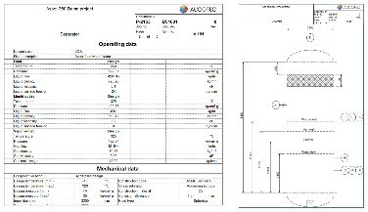
360-degree panorama of every desired asset: The new data sheets automatically merge all information about an asset, including accessories and sub-systems. (Picture (combines 2 sheet sections): AUCOTEC AG)

Alternative (same 2 sheet sections, separately):
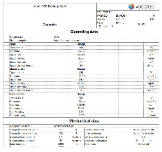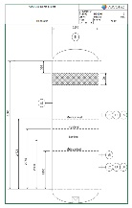
The variety of datasheet layouts is enormous. And they can contain over 100 sheets full of tables and graphics. The automatic processes of Asset 360 make it easy to handle this variety. (Source: AUCOTEC AG)

*These images are protected by copyright. They may be used for editorial purposes in connection with Aucotec.

If printed, we would appreciate receiving a copy. Thank you very much!
AUCOTEC AG, Hannoversche Straße 105, 30916 Isernhagen, www.aucotec.com
Press and Public Relations, Johanna Kiesel (jki@aucotec.com, +49 (0)511 6103186)

___________________________________________________________________________
Aucotec AG has over 35 years of experience in developing engineering software for the entire lifecycle of machines, plants and mobile systems. The solutions range from flow diagrams via I&C and electrical engineering for large-scale plants to modular harness design in the automotive industry. Aucotec software is in use all over the world. In addition to its headquarters in Hanover, Aucotec operates six further sites in Germany as well as subsidiaries in China, South Korea, France, Italy, Austria, Poland, Sweden, Norway and the US. A global network of partners ensures local support throughout the world.

