Press release
28 April 2020
10% increase for 35th birthday
Engineering software expert cautiously optimistic despite coronavirus crisis

Aucotec AG, an engineering software developer for exactly 35 years now, is still continuing to grow. Preliminary figures for the financial year which ended in March show a new record, with an increase in turnover of 10% compared to last year's all-time high. The independent software company even recorded an increase of 30% in terms of orders received.

"We have an excellent, highly motivated team and we have a sophisticated engineering platform that is in the right place at the right time," explained Management Board member Uwe Vogt with respect to the company's success. He thinks that now, in particular, it is meeting the enormous demand for "real" digitization in the designing of machines, plants and mobile systems.

Distributed engineering more important than ever
According to Vogt, digitization has recently become significantly more important: "This dire Covid-19 pandemic is also a driving force for digitization," he said. According to him, the ability to work consistently in a globally distributed manner on a joint project and a web-based overview of project progress for everyone responsible are more important than ever. These are basic principles of Aucotec's platform Engineering Base (EB), which are particularly relevant in times of compulsory working from home.

Support team increased for swift assistance
Aucotec has currently increased its support team for the provision of advice and support to its customers. The team helps swiftly and unbureaucratically, for example, in switching access from home workstations to the company's own license server. All in all, however, the number of requests has not increased significantly. "This shows how flexible and up-to-date EB is and that the system is keeping its promise to be an enabler for digitization at the highest possible level," said the Management Board member.

Full steam ahead through challenging times
Thus Uwe Vogt is cautiously optimistic, even if the economic effects of the global pandemic cannot be seriously predicted at the moment. The persons responsible at Aucotec are constantly monitoring and analysing developments and will extend measures if necessary. According to Vogt, Aucotec's ultimate goal is to continue full steam ahead to support customers and assist them in progressing on their digitization path: "To this end, we want to steer Aucotec and the entire workforce in such a manner through the challenging times that we will be optimally prepared for the continuation of our growth strategy after the crisis."

Links to the images*:
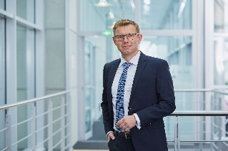
"With Engineering Base in the right place at the right time." Uwe Vogt, Management Board member of Aucotec (source: AUCOTEC AG)

Unity in plant engineering: Versatile data model parallelizes all core disciplines (source: AUCOTEC AG)

The versatile model in EB is the centre for all core disciplines in plant engineering and its direct communication with complementary systems (source: AUCOTEC AG)

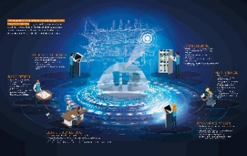

Digitization at the highest possible level: Central data model in Aucotec’s platform Engineering Base maps the digital twin over the entire lifecycle of a plant (source: AUCOTEC AG)

*These images are protected by copyright. They may be used for editorial purposes in connection with Aucotec.

If printed, we would appreciate receiving a copy. Thank you very much!
AUCOTEC AG, Hannoversche Straße 105, 30916 Isernhagen, www.aucotec.com
Press and Public Relations, Johanna Kiesel (jki@aucotec.com, +49 (0)511 6103186)

___________________________________________________________________________
Aucotec AG has over 30 years of experience in developing engineering software for the entire lifecycle of machines, plants and mobile systems. The solutions range from flow diagrams via I&C and electrical engineering for large-scale plants to modular harness design in the automotive industry. Aucotec software is in use all over the world. In addition to its headquarters in Hanover, Aucotec operates six further sites in Germany as well as subsidiaries in China, South Korea, France, the United Kingdom, Italy, Austria, Poland, Sweden and the US. A global network of partners ensures local support throughout the world.

