Project Builder automates plant configuration
New tool in Engineering Base alleviates skills shortage

The new Project Builder for Aucotec's Engineering Base (EB) software platform can make plant configuration even easier for planning professionals. The tool extends the Advanced Typical Manager (ATM) for EB, which can be used to define cross-discipline, function-oriented modules that make structuring and configuring plants very efficient. Individually configurable, the Project Builder now automatically instructs the ATM on the appropriate selection of typicals. The combination of tools increases the quality of the plant configuration and safeguards know-how.
Press Release
12 December 2023

Making selection easier
Until now, project planners either had to have in-depth knowledge of typicals and their complex designations themselves or call in experts to select the right ones. The Project Builder, on the other hand, can be configured for each plant type using conditions and rules, so that it has the necessary expertise on the "right" typicals for defined projects. As it also knows the components of the ATM modules, it automatically knows which one fits where. This not only speeds up the "clicking together" of plant projects of all kinds, but above all increases data quality, as misinterpretations of cryptic typical names can no longer occur. At the same time, there is no longer a need for specialists who know all the typicals including their functions and cryptic designations inside out. They are rare and are needed elsewhere. But the Project Builder also counteracts the shortage of skilled workers in another area:

Configurable configurator
The new configuration tool is not only configurable using rules. Users can also define their own user interface to suit their preferred workflow and individual requirements. Whether for project types or individual user interfaces, every configuration can be saved and can therefore be used again and again. This accelerates project processing even further and archives important knowledge, which significantly reduces the workload of the specialists.

Project and follow-up actions automatic
The configurator creates the project independently, then the ATM fills it with the appropriate typicals according to the "instructions" from the Project Builder. The new tool then takes over again and – depending on the configuration – can automatically start follow-up actions, such as generating terminal block diagrams, creating tables of contents or customizing the documentation structure. The Project Builder guides its users step by step through the plant configuration in an easy-to-understand manner. Each click takes them one level further until a field or an entire plant is fully defined and mapped in the data model. The tool also provides information about the consequences of a certain selection, for example: "If this point is clicked, only this constellation is possible in the next step."

Initial presentations of the concept to Aucotec's customers brought only positive feedback, because who doesn't suffer from high project pressure and a lack of resources? "There is obviously a great need for it, as the overwhelming response shows," reports Michaela Imbusch, Product Manager for Power Transmission & Distribution and one of the "mothers" of the solution.

Links to images*:

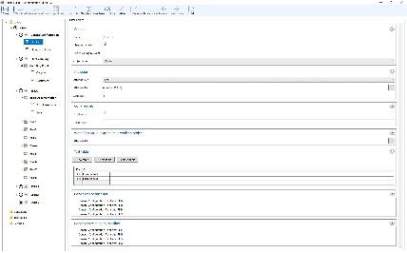
The editor in the Project Builder configures the tool via rules and defines what the user interface should look like.
(Image: AUCOTEC AG)

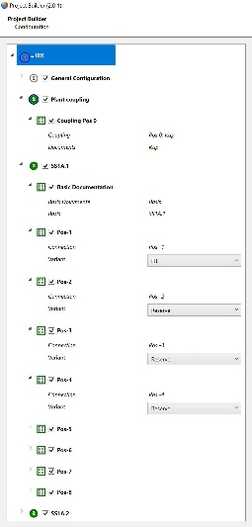
The configurator in the Project Builder provides the concrete selection of variants and the creation of the target project. (Image: AUCOTEC AG)

Michaela Imbusch, Product Manager at Aucotec: "There is obviously a great need for it, as the overwhelming response shows." (Image: AUCOTEC AG)

*These images are protected by copyright. They may be used for editorial purposes in connection with Aucotec.

___________________________________________________________________________
Aucotec AG has more than 35 years’ experience in the development of engineering software designed for use throughout the life cycle of machinery, plant equipment and mobile systems. Solutions range from flow diagrams and process-control/electrical technology for large-scale plant systems to modular on-board power supply units designed for the automotive industry. Software supplied by Aucotec is currently in operation throughout the world. In addition to the headquarters near Hanover, the Aucotec Group includes six other locations in Germany as well as subsidiaries in China, India, Malaysia, South Korea, the Netherlands, France, Italy, Austria, Poland, Sweden, Norway and the USA. What is more, a global partner network ensures local support all over the world.

We would be grateful if you could supply us with a copy of your article. Thank you very much!

AUCOTEC AG, Hannoversche Straße 105, 30916 Isernhagen, www.aucotec.com
Press and Public Relations, Johanna Kiesel (johanna.kiesel@aucotec.com, +49(0)511-6103186)

