Press release
17 September 2019

Equinor's engineers start digital transformation with Aucotec
Offshore expert opts for data-driven software platform

The engineering software developer Aucotec acquired a new major client in the oil, gas, wind and solar energy sectors: Equinor ASA, formerly Statoil, based in Stavanger, Norway, will be digitizing and maintaining its plants with Aucotec's data-driven, cooperative platform Engineering Base (EB) from now on.

Backbone of plant data
Equinor is one of the world's largest offshore operators, and also maintains refineries and wind farms. The company is undergoing a transformation process whereby the traditional document-oriented lifecycle information on the plants is becoming highly digital, centrally managed data. It is much easier to keep up-to-date, and maintenance is greatly facilitated.

"We're very proud that Engineering Base provides the backbone for the data relating to Equinor's plants and their maintenance. It was probably not entirely by chance that they named the EB project 'Spine'," said Uwe Vogt, Executive Officer at Aucotec. "We presented the new range of our platform for the first time at the last ACHEMA. The fact that Equinor is also one of the major new clients that we were able to impress with this is an outstanding endorsement of our team," stressed Vogt. The system covers all core disciplines of process engineering from FEED via basic and detailed engineering, DCS configuration and cause & effect support to maintenance.

Digital twin from over 350,000 documents
Equinor is starting to work with EB on the new Johan Sverdrup oil rig project, which will begin oil production at the end of 2019. It will exploit a huge oil field approximately 160 km from Stavanger, whose capacity is expected to last around 50 years. The plant, consisting of several platforms, will also have to work as efficiently as possible for a correspondingly long period of time and will always have to have up-to-date documentation.

"Equinor expects a significant simplification and thus an acceleration of maintenance work. Changes and collaboration with many subcontractors, whether in the design area or in operation, are much easier to implement and are more consistent with this unique master engineering database," explained the Aucotec Executive Officer. For this purpose, more than 350,000 Johan Sverdrup documents are being migrated to EB and digitally processed there.

Since all disciplines are covered by EB's object-oriented plant model, changes have only to be centrally entered once. Each representation of the modified object is automatically updated. "This is how EB contains the complete digital twin with all its logic, and not just a sub-discipline," said Vogt. "Not only EB, but also the whole Aucotec team won them over," he added.

Links to the pictures*:

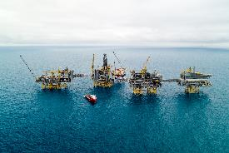 (Photo: Equinor/Espen Rønnevik/Øyvind Gravås)
With the upgrading of over 350,000 documents of the Johan Sverdrup offshore platform by Engineering Base, Equinor is starting their transformation into highly digital, centrally managed lifecycle data.

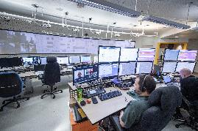 (Photo: Equinor/Michal Wachucik)
Control room of an Equinor offshore platform

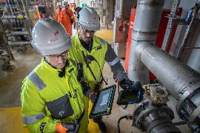 (Photo: Equinor/Michal Wachucik)
“Equinor expects a significant simplification and acceleration of maintenance work. Changes are much easier to implement and are more consistent with this unique master engineering database.”

(Photo: Aucotec AG)
"We're very proud that Engineering Base provides the backbone for the data relating to Equinor's plants and their maintenance." Uwe Vogt, Aucotec Executive Officer

*These images are protected by copyright. They may be used free of charge in connection with this press release. Otherwise the photos are subject to the conditions of the relevant copyright holder.
___________________________________________________________________________

Equinor ASA is the largest Norwegian operator of offshore platforms for oil and gas extraction – and one of the largest operators in the world. Its plants also include refineries and wind farms. Equinor is also Europe's second largest gas exporter. The company operated under the name Statoil up to 2018. Equinor operates in over 30 countries around the world, including the regions with the world's most important oil and gas reserves, and has over 20,000 employees. In addition to traditional oil and gas exploration as well as the sale of raw materials, Equinor is developing more and more solutions related to renewable energies.

Aucotec AG has over 30 years of experience in developing engineering software for the entire lifecycle of machines, plants and mobile systems. The solutions range from flow diagrams via I&C and electrical engineering for large-scale plants to modular harness design in the automotive industry. Aucotec software is in use all over the world. In addition to its headquarters in Hanover, Aucotec operates six further sites in Germany as well as subsidiaries in China, South Korea, France, the United Kingdom, Italy, Austria, Poland, Sweden and the US. A global network of partners ensures local support throughout the world.

If printed, we would appreciate receiving a copy. Thank you very much!
AUCOTEC AG, Oldenburger Allee 24, 30659 Hannover, www.aucotec.com
Press and Public Relations, Johanna Kiesel (jki@aucotec.com, +49 (0)511 6103186)

