Press Release
5 June 2018
Rule-based, spec-driven and pipe class-oriented:
Engineering Base guides you safely and quickly through the process design

With the latest version Engineering Base 2018 (EB) to be presented for the first time at ACHEMA´18, Aucotec AG has significantly expanded the process engineering of its platform. A special focus here is specification-driven tasks, combined with a pipe class catalogue.

Calculating: Drafz Consulting guarantees suitable pipe class
Pipe classes specify e.g. which pipes of which material must withstand which media and pressure-temperature ratios. As they are safety-relevant, a proven calculation of the class is mandatory. But this is enormously complex, and special requirements repeatedly require new pipe classes and calculations.

So Aucotec has decided on a partnership with Drafz Consulting GmbH. Their pipe classes, based on EN 13480 and DIN 21057 (former PAS 1057) and others, checked and extensively documented, can be easily imported into EB via a standard interface. "Drafz's data is excellently prepared. Their digitization level and database structure fit perfectly with EB, making all information in our platform easy to use," says Pouria Bigvand, senior product manager at Aucotec. Managing Director Achim Drafz adds: "Importing and mapping our data to EB works really quickly and without losses. This way EB users always have the guarantee that everything fits and is calculated correctly. Aucotec is a very uncomplicated, innovative partner!"
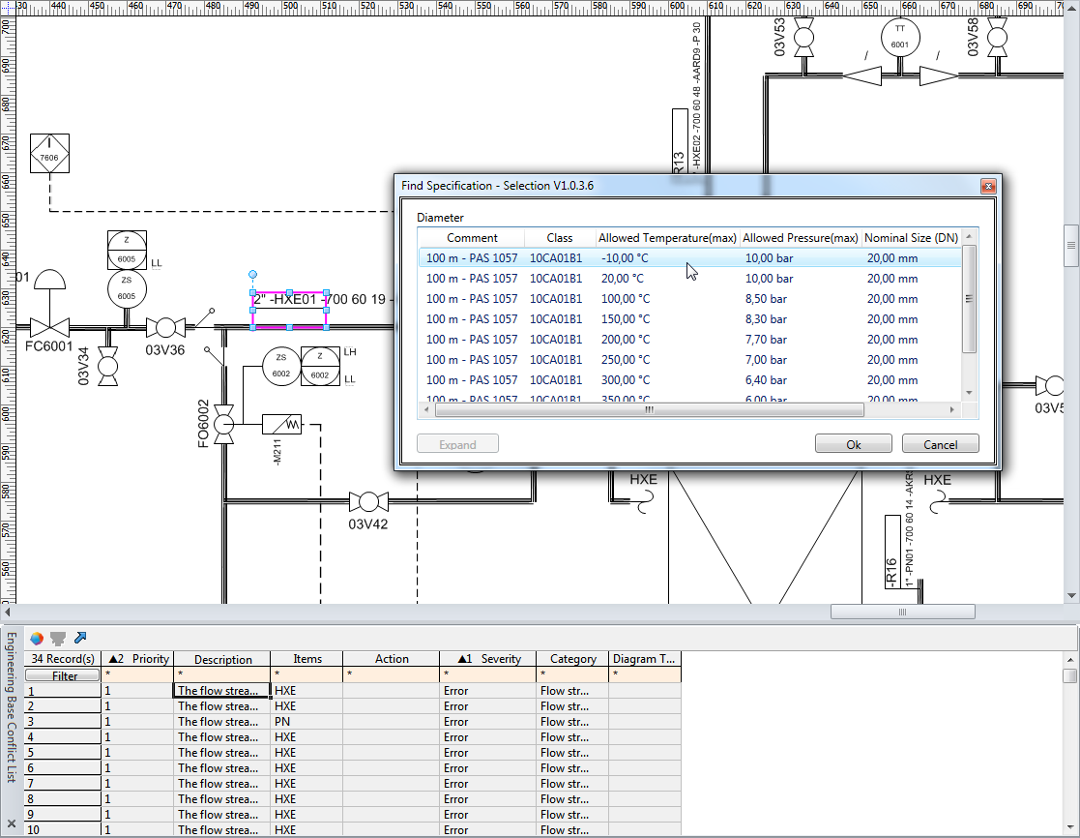

Organized: passing values on
In addition to the specification-driven workflow and class warranty, the new process engineering with EB 2018 also benefits from rule-based design. Here it can be specified what information is to be passed on from which object to where. This allows users to "propagate through" values, e.g. the diameter of a pump via the pipe, any flanges, reducers and the like. This works from device to device, but also from and to a function. These key data, which are automatically assigned to all objects included in the rule, further accelerates specification.

Special: faster specification
A new function enables the quick and safe selection of the correct pipe class via several filter levels building on one another. Filter attributes and comparison operators, e.g. "maximum pressure: greater than or equal to", can be freely defined in advance, as can the various levels. By clicking on a line in the P&ID diagram, a wizard opens with prefiltered selection showing all suitable items from the catalogue. Another click on the selected object immediately assigns this specification to the line. The specification data can be automatically passed on to other objects via self-configured rules.

More than complete
The new functions in EB and the connection to Drafz Consulting harmonize well with each other. "With this completion of the process engineering, EB is able to compete with the big players. If you add to this the bandwidth of the cooperative platform, with which all core disciplines of plant design are developed and managed non-stop in just one versatile data model in just one database, EB is absolutely unique," emphasizes Product Manager Bigvand.

Aucotec at ACHEMA: Hall 9.2, booth no. 12 B

Links to the images*:
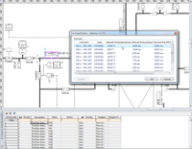

Specifying pipe classes more quickly: The assistant „Find Specification“ scans catalogues for fitting elements and allocates the selection to the pipe (© AUCOTEC AG)

Pouria G. Bigvand, Director of Aucotec’s Product Management (© AUCOTEC AG): "With this completion of the process engineering, EB is able to compete with the big players. If you add to this the bandwidth of the cooperative platform, EB is absolutely unique."

Achim Drafz, Managing Director of Drafz Consulting GmbH: “Importing and mapping our data to EB works quickly and without losses. This way EB users always have the guarantee that everything fits and is calculated correctly.”

*These images are protected by copyright. They may be used only for editorial purposes in connection with Aucotec.

If printed, we would appreciate receiving a copy. Thank you very much!
AUCOTEC AG, Oldenburger Allee 24, 30659 Hannover, www.aucotec.com
Press and Public Relations, Johanna Kiesel (jki@aucotec.com, +49 (0)511 6103186)
__________________________________________________________________
Aucotec AG has over 30 years of experience in developing engineering software for the entire lifecycle of machines, plants and mobile systems. The solutions range from flow diagrams via control and electrical engineering for large-scale plants to modular harness design in the automotive industry. Aucotec software is in use all over the world. In addition to its headquarters in Hanover, Aucotec operates six further sites in Germany as well as subsidiaries in China, South Korea, France, the United Kingdom, Italy, Austria, Poland, Sweden and the US. A global network of partners ensures local support throughout the world.

