Press release
24 October 2018

Aucotec lays foundation stone for new head office
More space for more employees after significant growth

Aucotec AG, independent developer of engineering software for over 30 years, is building a new head office near its current site in Hanover, northern Germany. Approximately 3,700 square metres over three floors will provide space for 160 employees as well as 12 state-of-the-art meeting and training rooms. Furthermore, an extension to include up to 110 additional workstations is already planned. Yesterday, the foundation stone was laid for the building which will require an investment of almost €12 million. The relocation is planned for February 2020.

Over 35% growth in number of employees
Ever since Aucotec, with its subsidiaries in Europe, Asia and the USA, has been growing significantly in recent years – about 80% more turnover and 35% more employees within six years – the old head office in Hanover (Lahe) has been bursting at the seams. Furthermore, an increase in turnover of around 20% in the first half of the current year indicates a continuing trend. The search for an adequate plot of land took over a year, and now the new Aucotec head office will be less than two kilometres from the existing site. However, it will then be located outside the state capital in neighbouring Isernhagen.

Including recreation to attract new colleagues
"We are delighted and proud that it is now finally getting off the ground," said Uwe Vogt, Management Board member for over 10 years, at the laying of the foundation stone. "The building will create a modern, cooperative work environment and the immediate proximity to Lake Altwarmbüchen will be inviting in terms of enabling employees to go on relaxing walks during their breaks. This will make Aucotec even more attractive as an employer. We are still looking for qualified colleagues for all areas, also for international assignments," said the Executive Officer. Canteens for employees and guests, small kitchens, a terrace and recreation room are also intended to create a communicative and relaxed environment.

Easily accessible
A tram line runs almost directly in front of the building, and electromobility will also be ensured. Some of the generously planned parking spaces are designed for electric charging stations. There will also be plenty of bicycle stands, some with electric charging facilities. They are intended to motivate the decision to engage in healthy exercise before and after work.

Isernhagen's Mayor, Arpad Bogya, is delighted about the growth from the IT sector within his community's relatively new industrial park spanning over 4 hectares. "We changed the planned subdivision of land to meet the needs of Aucotec. This has resulted in an area of approx. 8,600 m², which will be developed in a very attractive urban manner in close coordination between Aucotec and the local community." A total of 10 companies will be able to benefit from the favourable location of the site, with Aucotec using one of the largest plots.

Links to images*:
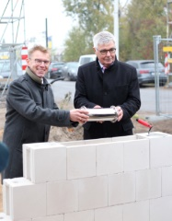
From left to right: Aucotec Executive Officer Uwe Vogt together with Chief Execution Officer and Aucotec founder Horst Beran at the laying of the foundation stone for Aucotec's new head office

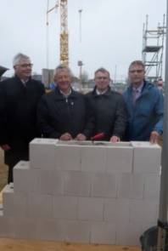
From left to right: Aucotec Chief Executive Officer Horst Beran, Isernhagen's Mayor Arpad Bogya, Aucotec Executive Officer Uwe Vogt and Michael Frerking, Head of Isernhagen’s Economic Development Department, at the laying of the foundation stone for Aucotec's new head office

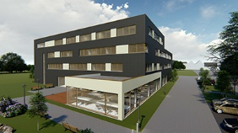
Rear view of Aucotec's new head office with canteen (© AUCOTEC AG)

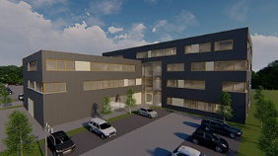
Generous parking spaces are planned for Aucotec's new head office as well as charging stations for electromobility – on both 4 and 2 wheels. (© AUCOTEC AG)

*These images are protected by copyright. They may be used free of charge for editorial purposes in connection with Aucotec.

If printed, we would appreciate receiving a copy. Thank you very much!
AUCOTEC AG, Oldenburger Allee 24, 30659 Hannover, www.aucotec.com
Press and Public Relations, Johanna Kiesel (jki@aucotec.com, +49 (0)511 6103186)

___________________________________________________________________________
Aucotec AG has over 30 years of experience in developing engineering software for the entire lifecycle of machines, plants and mobile systems. The solutions range from flow diagrams via control and electrical engineering for large-scale plants to modular harness design in the automotive industry. Aucotec software is in use all over the world. In addition to its headquarters in Hanover, Aucotec operates six further sites in Germany as well as subsidiaries in China, South Korea, France, the United Kingdom, Italy, Austria, Poland, Sweden and the US. A global network of partners ensures local support throughout the world.

