06 February 2017
Press release
Engineering with a view to flying high
Harness design experts of the aerospace industry meet at Aucotec's Technology Day

At the seventh Aucotec Technology Day in Hanover in January, experts from Airbus Defense & Space, OHB System AG, Thales Alenia Space, Sysberry and CADPart spoke about how they tackle the increasingly complex challenges of harness design for the aerospace industry. How does one become faster and better at the same time? Is there any engineering software without restrictions for the perfect workflow? Participants from Germany, France and the Netherlands were interested in the responses to these questions.

Secure database for mass data
All experts identified the need to cope with the enormous amounts of data which are involved in the design of complex aerospace projects. The speakers all had their use of the host's software platform Engineering Base (EB) in common. Airbus, Thales and OHB System AG reported on their focuses and approaches. Aucotec's partners Sysberry and CADPart spoke about their support for customizing and 3-D connection. The consensus was that EB's database-driven nature was virtually THE precondition for efficiency - including consistently assured data quality even with large amounts of data - as well as for the top-down approach required in system engineering.

“Data at the heart, not documents"
At the outset, Aucotec's Executive Officer for Engineering Uwe Vogt stressed the need to change. “Without it, we would still be using Otto Lilienthal's gliding technology of 125 years ago," he said. And: "The development of Industry 4.0 does not stop at aerospace." Complexity, time pressure and lack of resources required rethinking within the development process, and a departure from rigid document-centric thinking. "The data must be at the heart of the process. Only one data model open for all participants allows simultaneous, collaborative engineering across disciplines and sites," explained Vogt. He stressed the current reality where documents are only a further representation of the data. In addition, changes have to be made at only one point.

Top-down from system engineering to production
The aerospace experts used practical examples to illustrate how this can work. Each speaker highlighted a different engineering focus. This demonstrated the range of possibilities of data-driven work and open software architecture. The speakers proceeded to formulate a whole series of ensuing benefits: whether in terms of flexibility and unique freedom of the workflow design, support for the top-down approach to the mapping of different levels of detail or the essential minimization of interfaces and manual labour, for example, through the automatic and graphic representation of wiring from the list data. All of these benefits save time and improve data quality from the initial system concept to production, and not only for those involved in the construction of satellites and space shuttles.

3-D consistently integrated
The major value of significantly reduced manual labour was confirmed by a representative of the engineering service provider Sysberry, an Aucotec partner with a wealth of experience in aerospace. In addition, he spoke about what he experienced as the particularly easy customization of the software to customer-specific requirements.
1/3
CADPart's focus is on linking harness design to the realm of mechanical engineering. This is done via the Harness Integration Manager (HIM Pro). It enables an automated, bi-directional data exchange between 2-D and 3-D. According to the CATIA experts, electrical and mechanical engineering are thus provided with the respective optimal functions and can combine both sides in a structured, secure process.

"I was thrilled with the implementation of HIM," said one participant who, like everyone else, not only listened attentively, but used the breaks to engage in intensive discussions and make individual enquiries. The expert in issues relating to flight inspection systems and process control for the aerospace industry concluded as follows: "The day was highly interesting. I was surprised by the number of participants from the most diverse companies in the aerospace sector."

Additional offer (instead of paragraph 4): Specific statements of the aerospace companies

Different focuses – one solution
At Airbus Defense & Space, where EB is the standard harness tool for all Earth observation and scientific projects, the main focus, for example, is on the flexibility of the system and the freedom of the workflow design. Instead of having to adjust the design process to the system, EB adapts to the Airbus workflow.

A representative of OHB System AG, which currently "only" implements the harness design of satellites with EB, explained their next expansion phase of its use. In future, the workflow will be already started in EB for system engineering, followed by block diagrams and the detailed circuitry. The avoidance of data discontinuities significantly accelerates processes and ensures comprehensibility.

Thales Alenia Space left it to the Managing Director of Aucotec's French subsidiary, Djibi Dia, to speak about the enormous saving of time achieved by EB's automatic visualization of the wiring of their space shuttles and satellites. His speech referred to the current situation where graphics are created directly from the data of wiring lists, making multiple entries and thus time-consuming, error-prone manual labour a thing of the past.

Links to the images*:

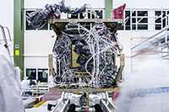
About 1,000 connectors, over 31,000 contacts, 2,500 cable segments, and 230 drawings: Cabling of the Airbus satellite Sentinel-2A with Aucotec's Engineering Base (source: Airbus DS GmbH)

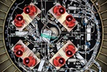
More than: 1,500 connectors, 46,000 contacts, 4,400 cable segments, 330 drawings - Cabling of the Airbus satellite EarthCARE with Aucotec's Engineering Base (source: Airbus DS GmbH)

2/3
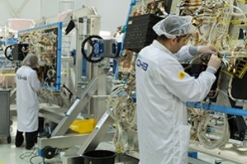
OHB System AG team at Galileo FOC satellite. OHB System AG creates the harness design using Engineering Base from Aucotec (© OHB System AG)

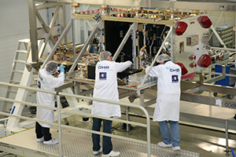
Galileo integration at OHB System AG in Bremen. The digital harness design is created in Engineering Base from Aucotec (© OHB System AG)

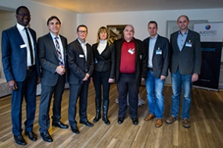
The speakers (from left: Djibi Dia (Aucotec, for Thales Alenia Space), Dr. Anton Ferner (CADPart), Jérôme Anguenot (Aucotec, for Thales Alenia Space), Birgit Smuda (Sysberry), Benjamin Lamey (OHB System AG), Tim Hoffmann (Sysberry), Martin Huber, Airbus Defence and Space (© Aucotec AG)

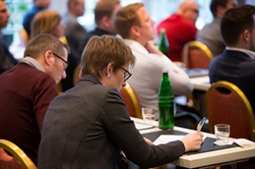
Attentive participants at Aucotec's Aerospace Technology Day in January 2017 (© Aucotec AG)

Uwe Vogt, Executive Officer at Aucotec (© Aucotec AG)

*These images are protected by copyright. They may be used only for editorial purposes in connection with Aucotec.

If printed, we would appreciate receiving a copy. Thank you very much!
AUCOTEC AG, Oldenburger Allee 24, 30659 Hannover, www.aucotec.com
Press and Public Relations, Johanna Kiesel (jki@aucotec.com), +49 (0)511 6103-186
___________________________________________________________________________
Aucotec AG has over 30 years of experience in developing engineering software for the entire life cycle of machines, plants and mobile systems. The solutions range from flow diagrams via control and electrical engineering for large-scale plants to modular harness design in the automotive industry. Aucotec software is in use all over the world. In addition to its headquarters in Hanover, Aucotec operates six further sites in Germany as well as subsidiaries in China, South Korea, France, the United Kingdom, Italy, Austria, Poland, Sweden and the US. A global network of partners ensures local support throughout the world.

3/3

