12 December 2016
Press release
Change needs networking, networking needs central data
Methods for optimizing processes in engineering

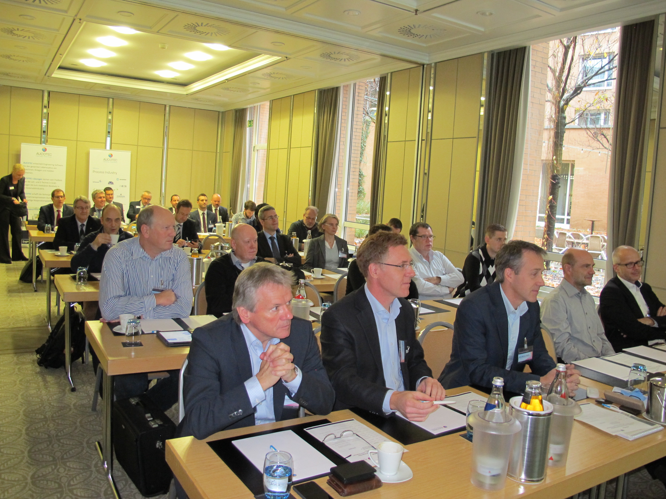The departure from data islands in engineering, building bridges between disciplines and to suppliers, networking, consistent data flow: these were the buzzwords which cropped up repeatedly throughout the presentations and discussions at the sixth Aucotec Technology Day in November. The event in Munich was attended by representatives from manufacturers of waffle machines to submarines based in locations from Kiel to Vienna. Representatives of such companies as Brückner, TBP, Areva, Haas Food Equipment and R. Stahl presented their respective methods for process optimization.
The sixth Aucotec Technology Day was attended by representatives from manufacturers of waffle machines to submarines based in locations from Kiel to Vienna.

Although their products are so different, their challenges are very similar. Big data and manual labour or "Excel engineering" have long since ceased to be compatible as digitization, the path to Industry 4.0, requires tools that create an overview, ensure data quality and also support international cooperation. The system platform Engineering Base (EB) from Aucotec, which is used for different primary purposes in each of the five companies, is such a tool.

Cooperation is everything
In their presentations, the practical experts repeatedly stressed the need not only for mechanical and electrical engineering to speak the same language, but also for other disciplines to be incorporated seamlessly without resulting, for example, in nomenclature problems. It should also be possible to manage globally distributed tasks cooperatively and simultaneously without losing an overview, consistency or changes.

Everything is worth nothing without a single source of truth
The practical examples showed that interdisciplinary work is only really efficient when the cooperating partners work with a common data model, a "single source of truth". The consistency of the processes with the database-driven EB can range from sales via costing to production. "For efficient processes, we have to network in order to use shared resources," was how Michael Eder, Head of CAD/CAM/CAE at Haas Food Equipment, summed it up in a nutshell.

This also includes the seamless integration of engineering into the ERP landscape, a topic on which several speakers reported. Automated interfaces which can be customized to the workflow ensure high transparency on both sides. Another point which was repeatedly mentioned as a prerequisite for efficient engineering was EB's ability for functional orientation and the convenient support of the standard IEC 81346.

From the graphics to the data
In order to satisfy the requirements of mass data and complexity, the effective work with typicals and easily comprehensible change and status management are key elements with which EB achieves one thing above all else for the different companies, namely the saving of time. The fact that EB's basic concept makes the data, rather than the graphics, the focus of the design is regarded by all participants as fundamental for time-saving and more consistent processes. It is also the basis for the way towards a digitized future.
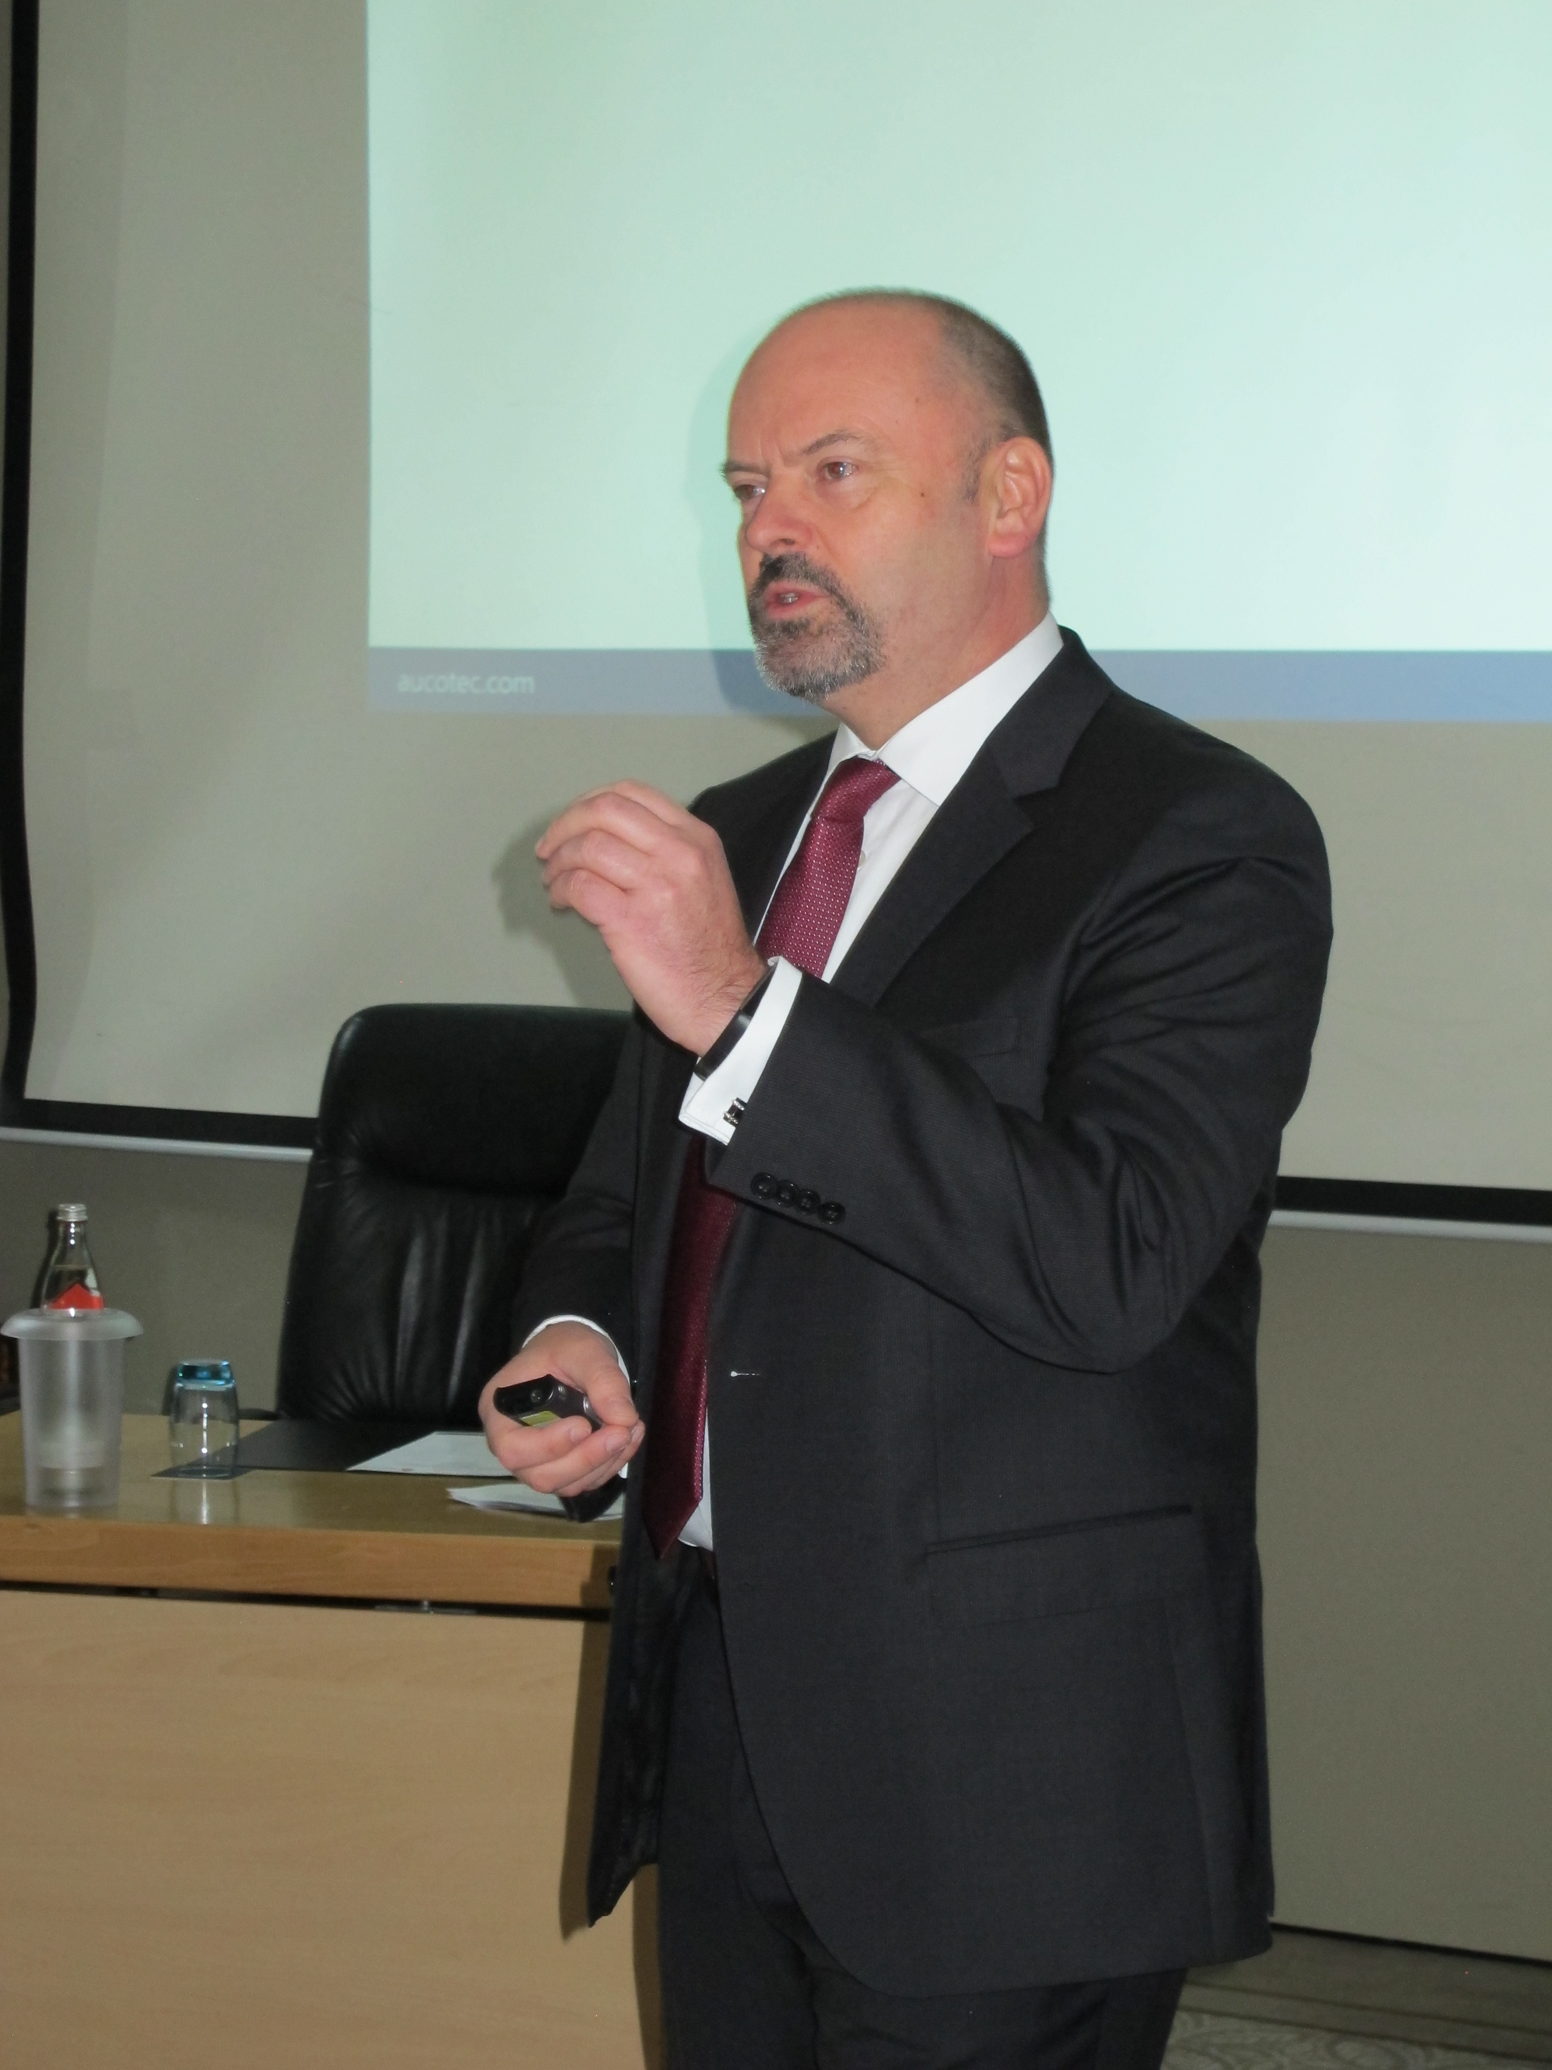
Focus on processes
"We are all in a state of flux; digitization is a great opportunity if one sets the right course in good time," said Management Board member of Aucotec Markus Bochynek at the Technology Day. In his opinion, it is crucial to focus on the processes because they offer the greatest potential for increasing efficiency. He stressed that product innovation alone is not enough, as Henry Ford already proved. Change is unmanageable without networked cooperation, networking in turn requires digitization. "Thus the data itself and the "single source of truth" have a crucial role in this process of change. Today's examples illustrate that clearly," said Bochynek.

The software company Aucotec AG uses the Technology Day series to regularly invite representatives from various industries to discuss their experience in relation to the current challenges for modern engineering. The focus is always on customers who present their ideas, innovations and initiatives about using the software and have open discussions with participants.

